**Lab-05**

**Name of Lab:** To Create Two LAN and Connect Them Using a Router

**Theory:**

A local area network (LAN) is a collection of devices connected together in one physical location, such as a building, office, or home. A LAN can be small or large, ranging from a home network with one user to an enterprise network with thousands of users and devices in an office or school.

A router is a device that connects two or more packet-switched networks or subnetworks. It serves two primary functions: managing traffic between these networks by forwarding [data packets](https://www.cloudflare.com/learning/network-layer/what-is-a-packet/) to their intended [IP addresses](https://www.cloudflare.com/learning/dns/glossary/what-is-my-ip-address/), and allowing multiple devices to use the same Internet connection.

**Steps involved in Creating Two LAN and Connect Them Using a Router**

**Step 1:**

We opened the cisco packet tracer and it looked like figure below which is also the initial phase.

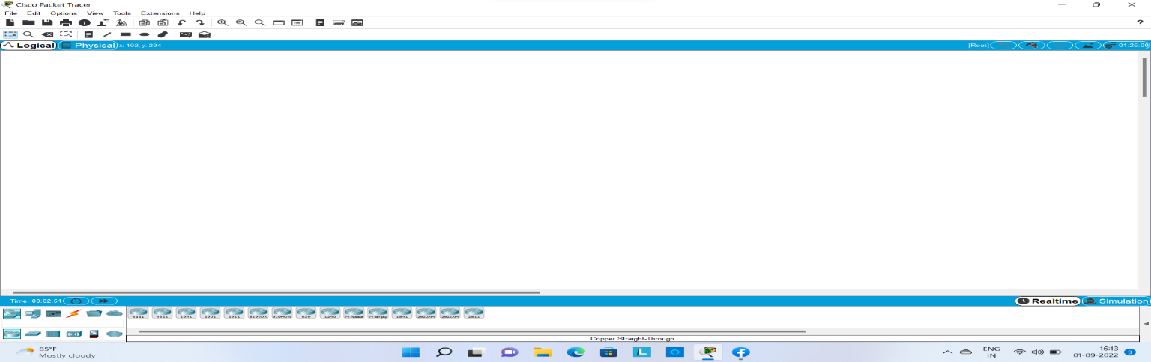

**Step 2:**

Then we added network device in order to create two LAN network and it look like figure below:

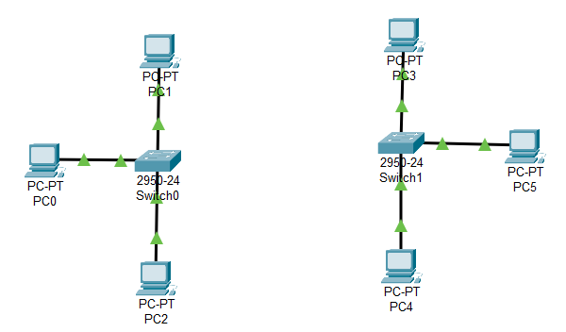

**Step 3:**

In this step we added router so that two LAN can be connected as shown in figures below:

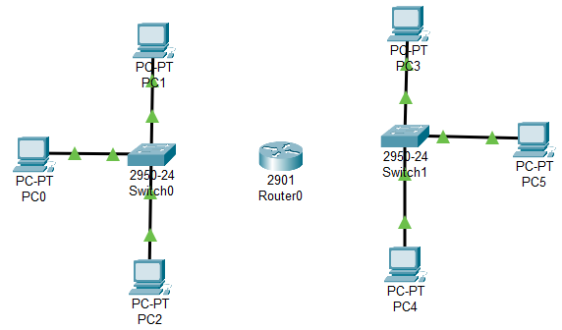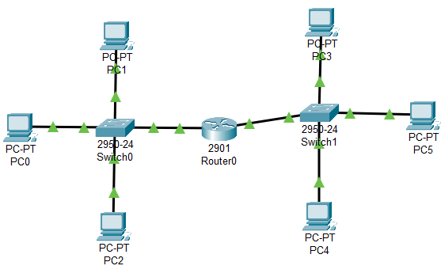

**Step 4:**

In this step we have assigned the device with internet protocol address (IP) as well as gateway address to all device of LAN1 in same way as shown below:

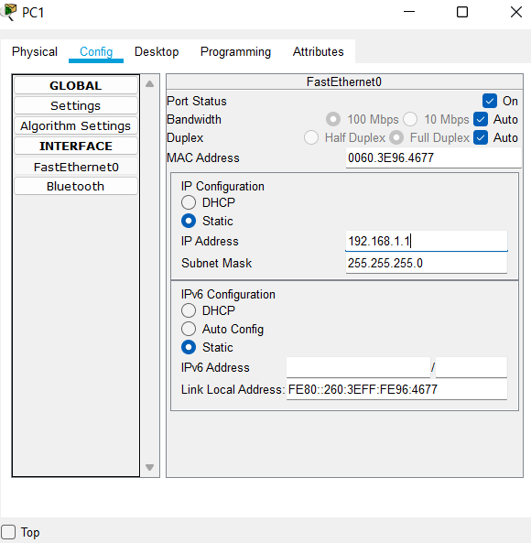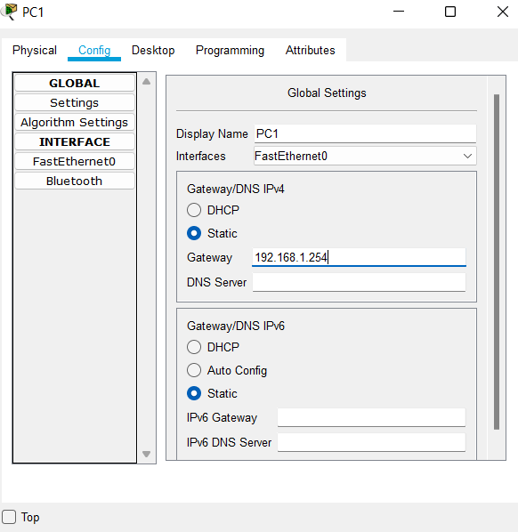

**Step 5:**

In this step we have assigned the device with internet protocol address (IP) as well as gateway address to all device of LAN2 in same way as shown below:

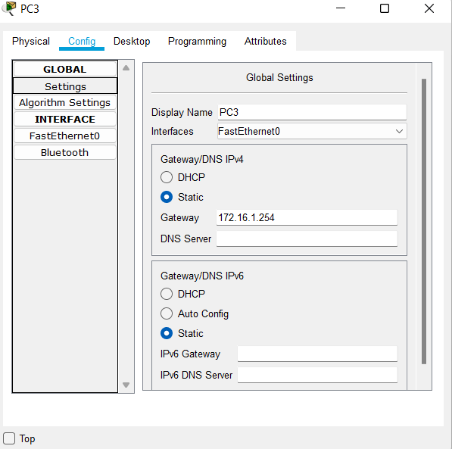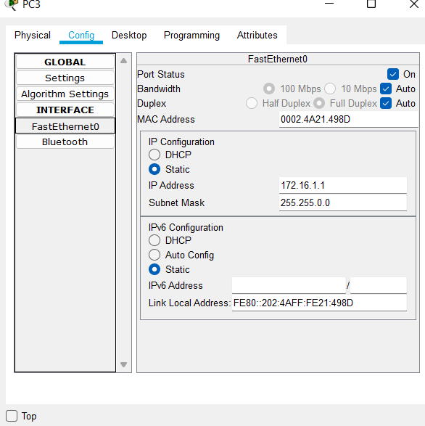

**Step 6:**

In this step we have configured the router in order to established the connection between two LANs as shown in figure below:

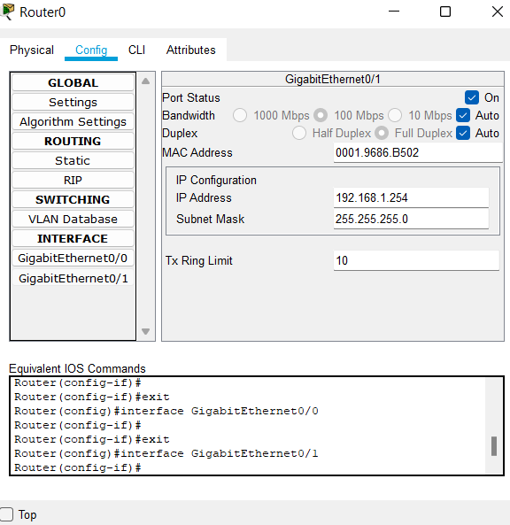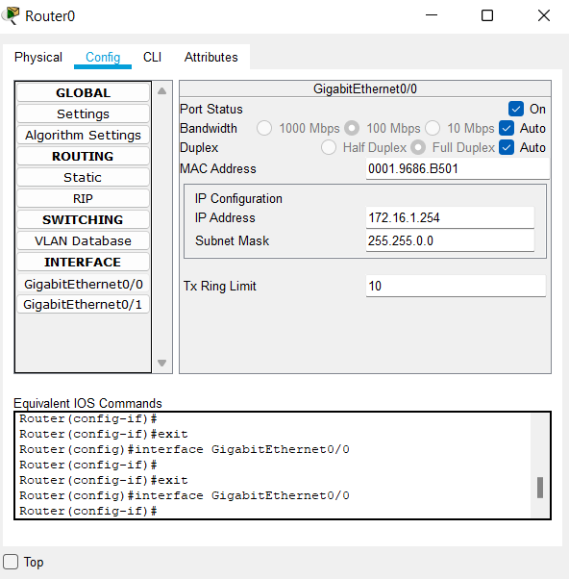

**Step 7:**

Verifying the connection between the networking by ping the device with eachother as shown below:

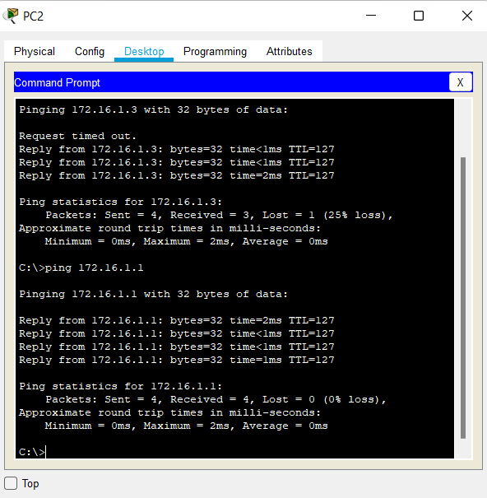

**Step 7:**

Verifying the connectivity by the process of **simulation** and various steps of simulation are shown below:

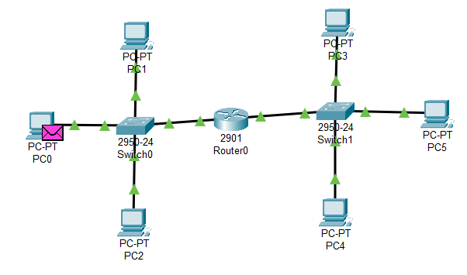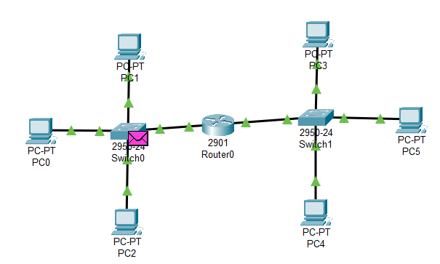

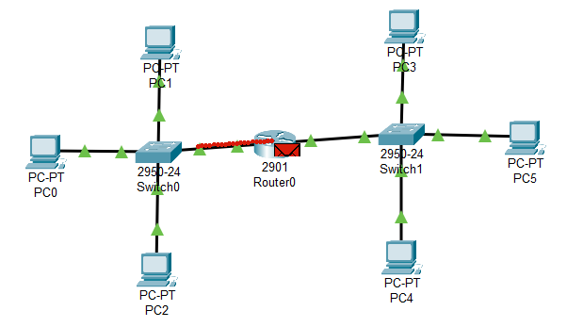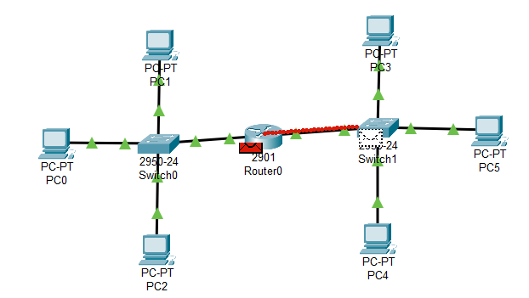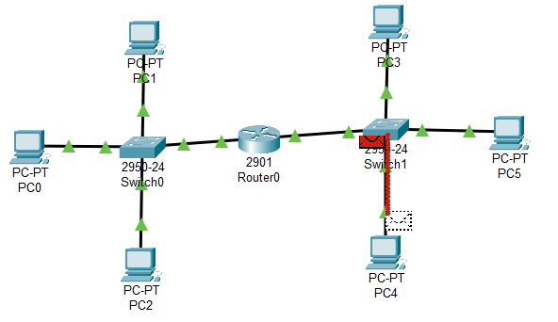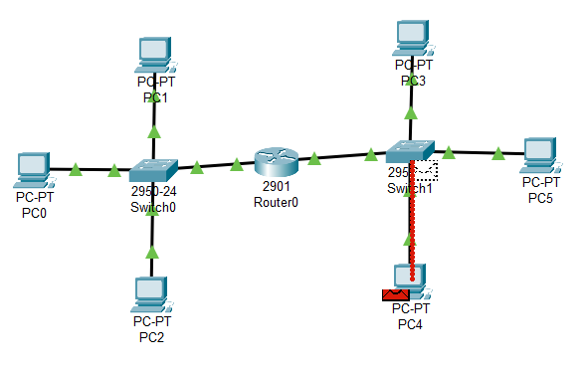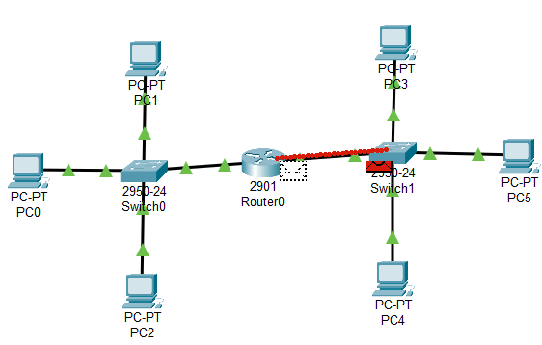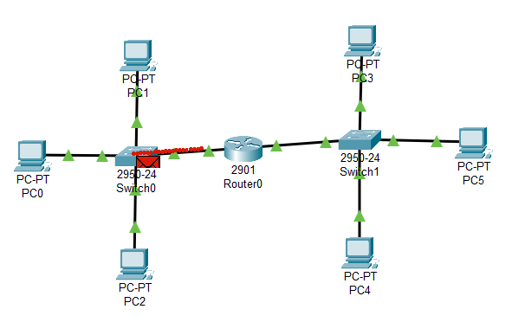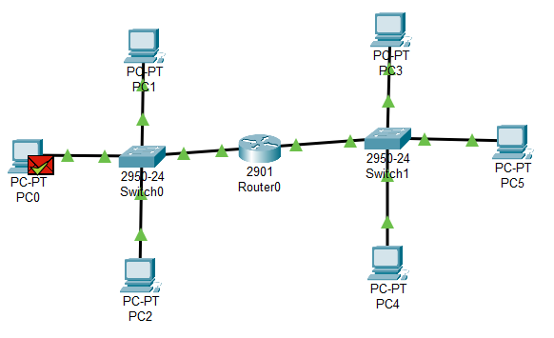

**Conclusion:**

Here in this, lab we came to conclude how Create Two LAN and Connect Them Using a Router and verified their connectivity.